**ACTIVITY 4: CREATE DATA LOOKUP**

Click on All >> Data Lookup Definition

Enter the name as “program data lookup”.

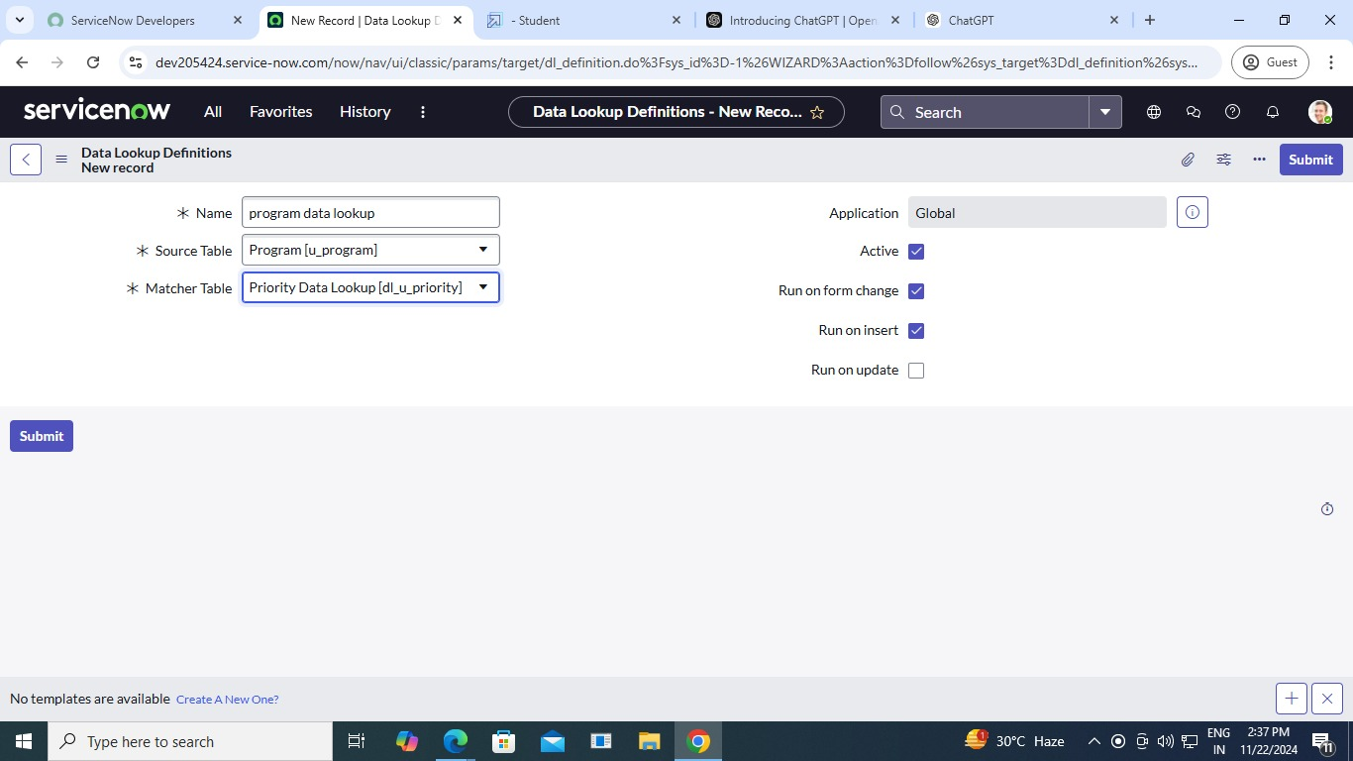

Configure matcher field definition.

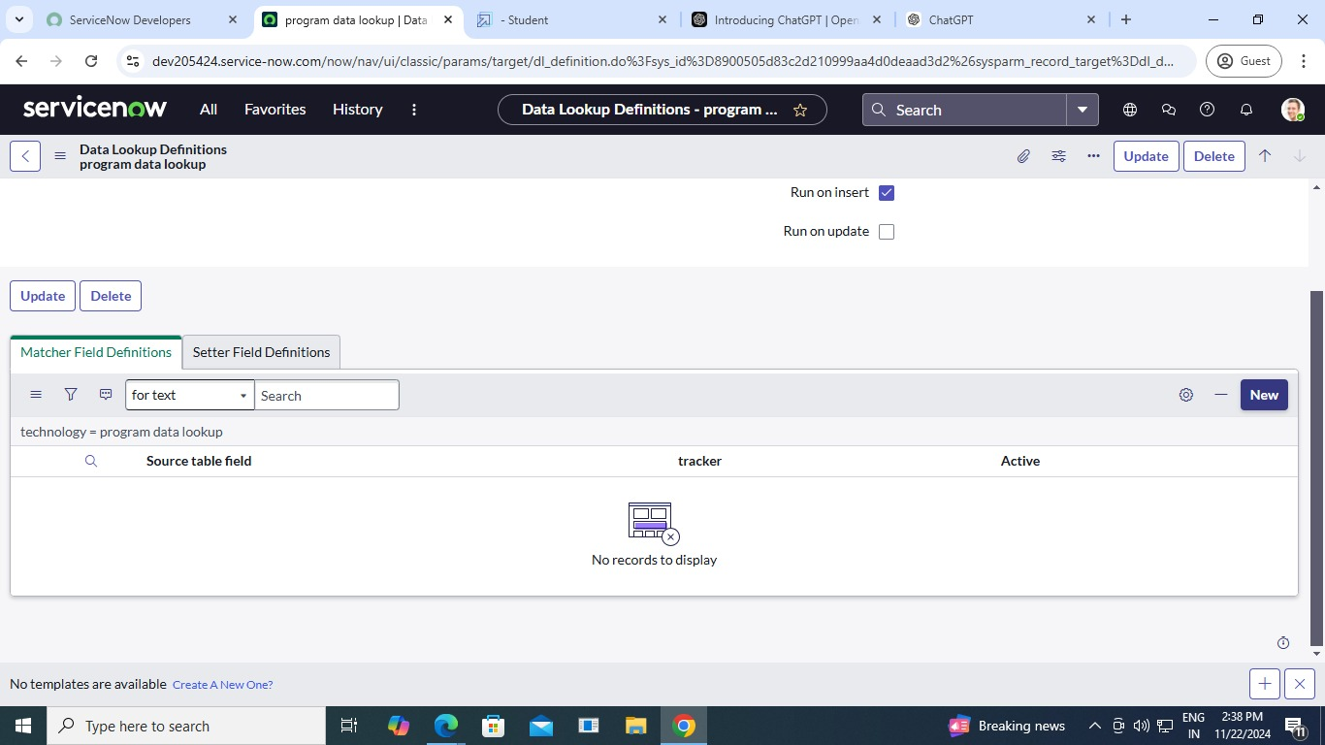

Step 2:

